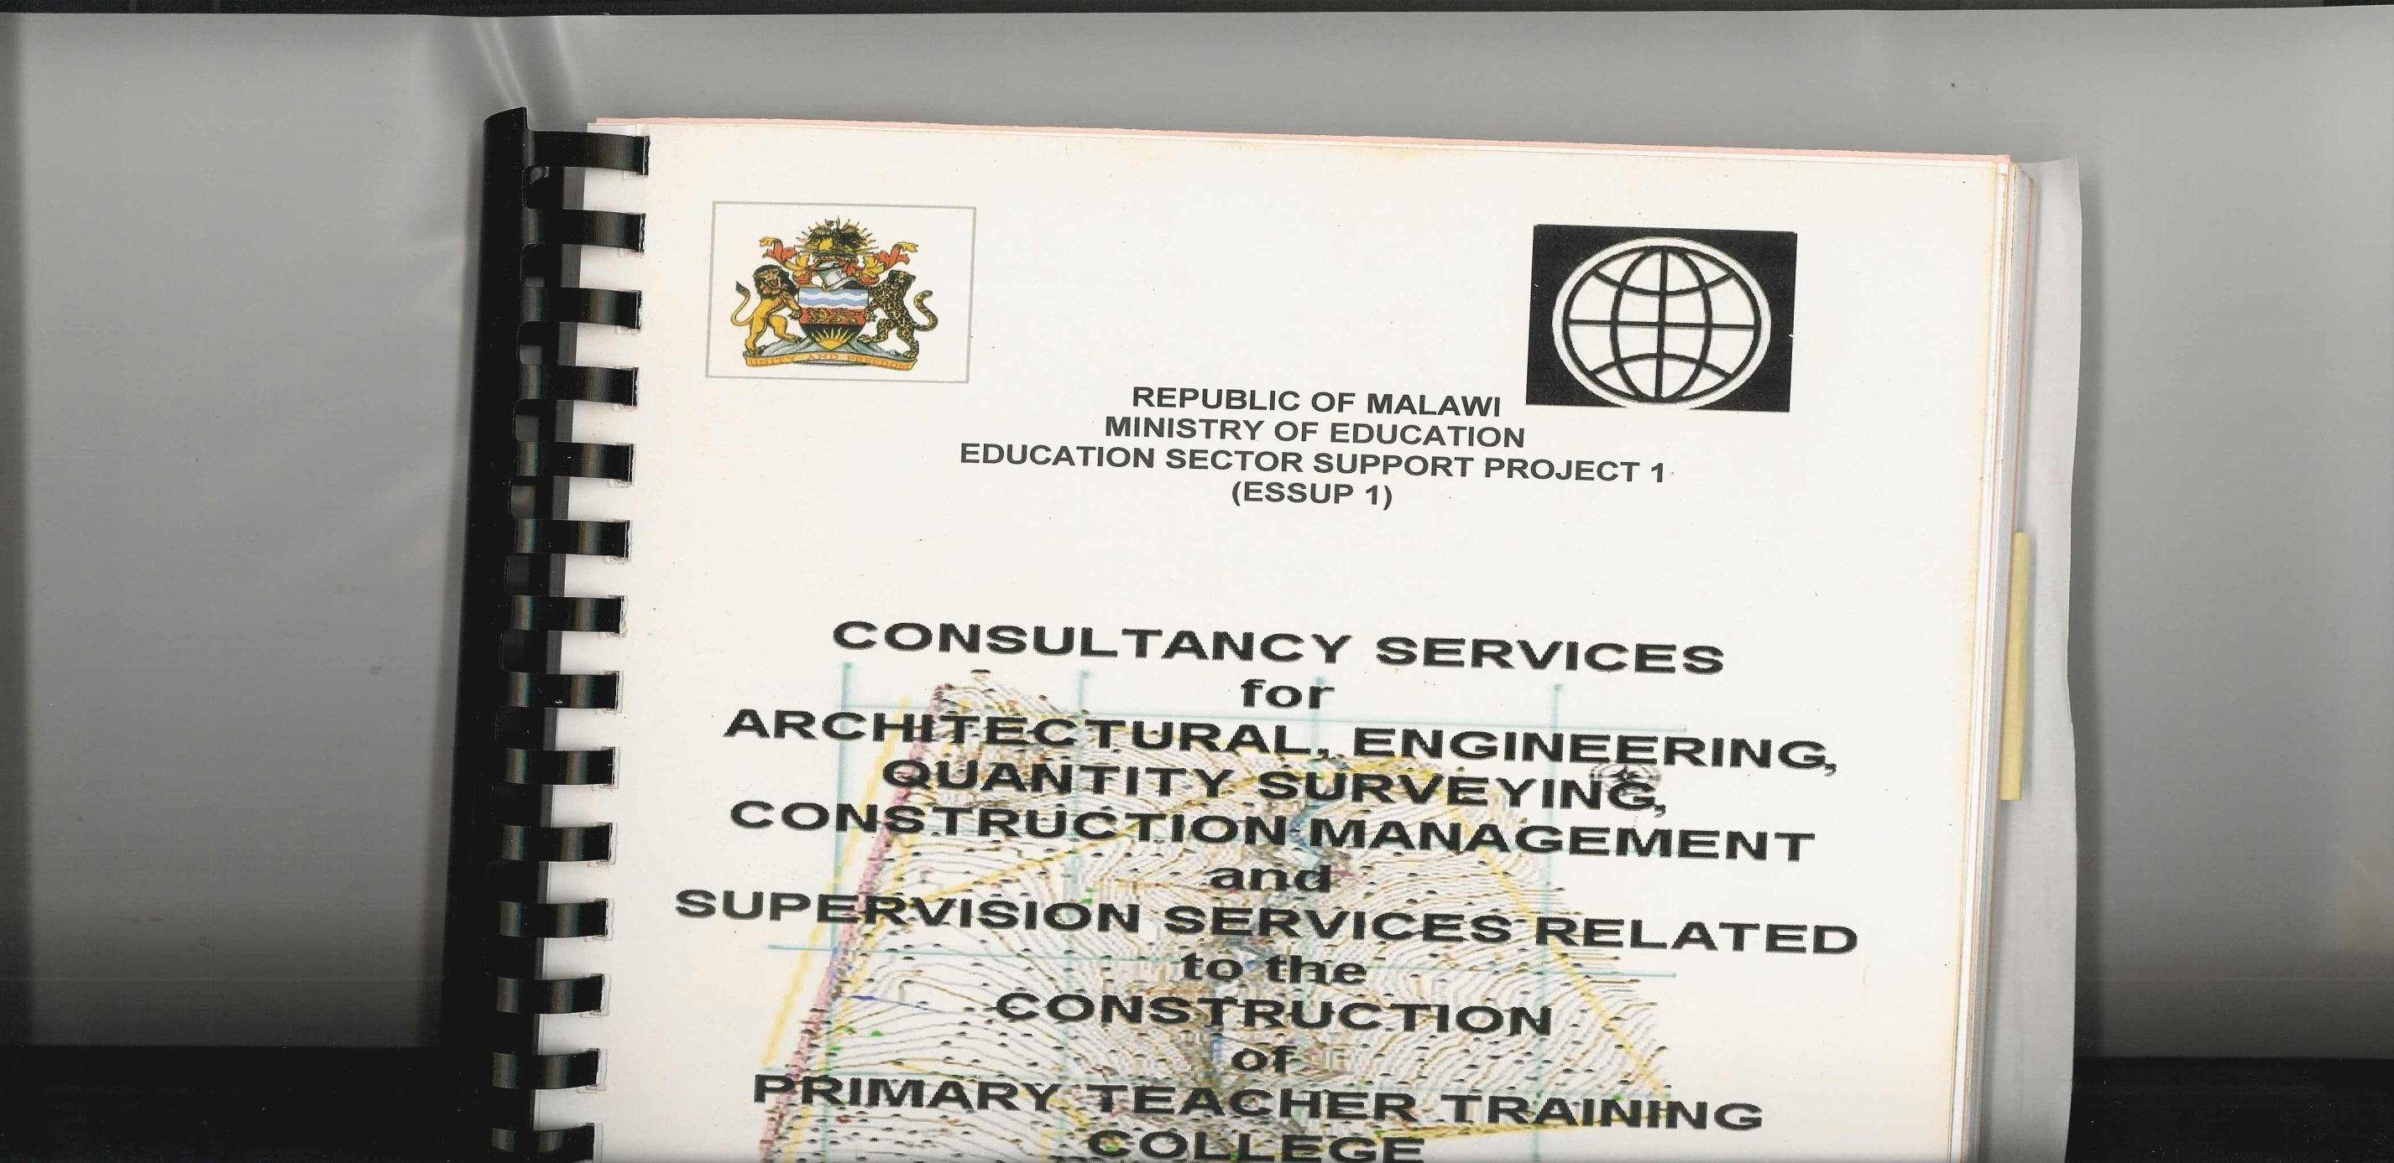

**SPEECH BY**

**DR. EMMANUEL FABIANO, M.P.**

**THE HONOURABLE MINISTER OF EDUCATION, SCIENCE AND TECHNOLOGY,**

**AT THE 11TH CONFERENCE OF THE SOUTHERN AFRICA ASSOCIATION FOR EDUCATION ASSESSMENT (SAAEA) 2017**

**ON**

**MONDAY**

**17TH JULY, 2017**

* **The Secretary for Education, Science and Technology, Dr. Ken Ndala;**
* **Dr. Michael Chilala, Chairperson of SAAEA and Director of Examinations Council of Zambia (ECZ);**
* **The Chairperson of Malawi Parliamentary Committee on Education, Science and Technology, Hon Dr. Elias Chakwera, M. P., and fellow Honourable Committee Members.**
* **The Chairperson of the Malawi National Examinations Board, Prof. John D. Kalenga Saka;**
* **The Acting Executive Director of Malawi National Examinations Board, and your staff;**
* **The Chief Executive Officer of our hosting partner of this conference, the Institute of Chartered Accountants in Malawi (ICAM) and your staff;**
* **Chief Executive Officers of SAAEA member institutions and your delegations;**
* **Chief Executive Officers and Directors of Education Institutions in Malawi;**
* **The District Commissioner for Mangochi;**
* **The District Education Manager for Mangochi;**
* **The Chairperson of the Local Organizing Committee of this conference and committee members;**
* **Distinguished delegates;**
* **Members of the Press;**
* **Ladies and gentlemen;**

**Good Morning!**

I am very pleased and feel honoured this morning to be with you here at Nkopola Lodge in Mangochi to officially open the 11th Southern Africa Association for Educational Assessment (SAAEA) Conference which Malawi Government through the Malawi National Examinations Board (MANEB) is hosting together with the Institute of Chartered Accounts in Malawi (ICAM).

First of all, let me join the previous speakers in welcoming you all, to this conference. I am grateful that out of your busy schedules you decided to come and be part of this important get together.

**Chairperson, Distinguished Delegates, Ladies and** **Gentlemen**,

The vision for the Education Sector in Malawi is to be a catalyst for socio-economic development, industrial growth and an instrument for empowering the poor, the weak and the voiceless. This vision is in line with the Sustainable Development Goal number 4, and the 1998 SADC Protocol on Education and human resource development. In order to achieve this, the Government of Malawi came up with the National Education Sector Plan (NESP), a policy to guide the provision of education in the country at all levels, between 2008 and 2017. To realise its vision and mission, the education sector has defined three thematic areas of intervention during the period of its implementation. The thematic areas are; to:

* Expand equitable access to education to enable all to benefit,
* Improve quality and relevance of education, to reduce drop-out and repetition and promote effective learning, and
* Improve governance and management of the system to enable more effective and efficient delivery of education services.

**Ladies and Gentlemen,**

To operationalise the NESP, my ministry developed the Educational Sector Implementation plan I and II. The main objective of the Education Sector Implementation Plan (ESIP) II is to improve learning outcomes. MANEB’s role in ensuring that only those learners who possess the requisite learning outcomes get certified; are, where applicable, selected; and get places in the next level of the education system cannot be over-emphasized. I should believe these roles are true about most of the examination systems in our sub-region and beyond.

MANEB is therefore at the core in ensuring that quality assurance is guaranteed in the school system in Malawi. To complement the role of MANEB, my Ministry has developed the Education Standards and facilitated the enactment of the 2012 Education Act. These pieces of legislation have created legal framework for the principles of access and equity, quality and relevance, and governance and management of the education sector.

**Ladies and Gentlemen,**

As Malawi is implementing the three pieces of legislation, we are very much aware of the need to develop the National Qualifications Framework which would make it possible for us to manage the so many qualifications that have mushroomed with the advent of market liberalisation. We are furthermore aware that the whole SADC Sub-region is pulling efforts together in order to link country-specific qualification frameworks into a sub-region qualifications framework.

The government through my ministry is in the final stages of developing the Malawi Qualifications Authority bill. The bill intends to create a legal framework for managing the National Qualifications Framework.

**Ladies and Gentlemen,**

The Malawi Qualifications Authority bill once enacted into law will bring both positives and negatives to MANEB. For instance, the Government may liberalise the provision of national examination services in the country. Hence, MANEB will have to live a life of having a competitor over the number of candidates. As Government, we believe that the competition will be good for service delivery. However, MANEB has the advantage to start repositioning itself before that competitor is born. I would therefore like to agree with the Chairperson of MANEB that the development of the Strategic Plan is a development in the right direction because the path that MANEB has decided to take will put the institution at a position of competitive advantage.

**The Chairperson, Ladies and Gentlemen**

I am sure that the same internal issues and external threats besieging MANEB apply to examining and assessment bodies in the rest of the SADC countries. What is pleasing to note is that, as an association, you have already started discussing ways and means of addressing these issues and threats, thereby not only will you find solutions for improving quality of the examination and assessment services but also solutions with which to address the system bottlenecks. My ministry will continue supporting these endeavours for the good of our nation and indeed the entire SADC Sub-region.

**Chairperson, Ladies and gentlemen,**

I did not intend to make a lengthy speech but rather to share with you the issues I have presented so that you may wish to deliberate over them in these next three days.

I would like, once again, to welcome each one of you to Malawi, the warm heart of Africa. Find time to swim in the beautiful waters of Lake Malawi, and also do not forget to taste our delicious Chambo fish when it is put on the menu.

At this point, let me take this opportunity to express my Ministry’s profound gratitude to our sponsors, both foreign and local, for the financial and material support provided for this conference. So too to all delegates foreign and local, you have made the conference a reality.

With these few remarks, it is now my privilege and honour to declare the 11th SAAEA Annual Conference officially open.

**I thank you for your attention.**